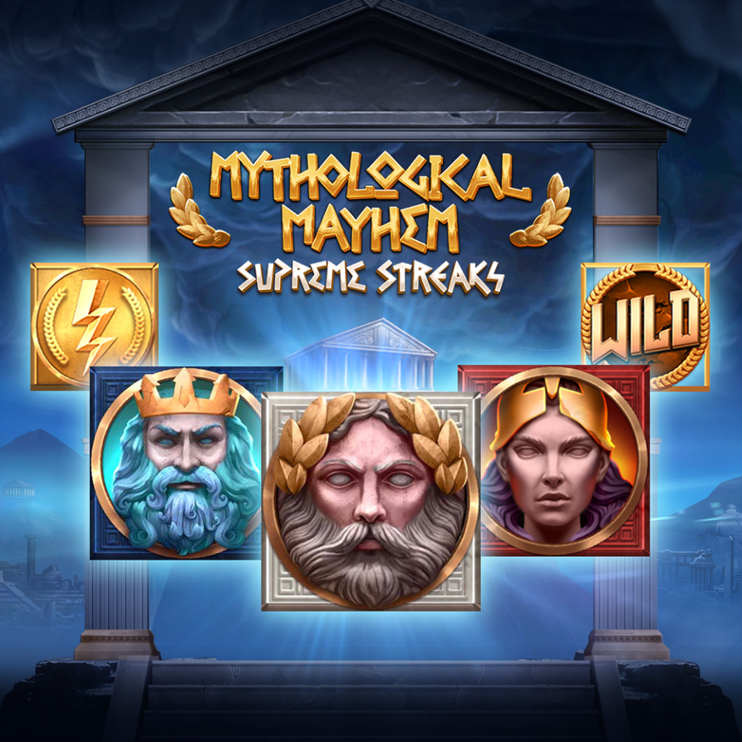

GAME INFO
Game Name: Mythological Mayhem
GameID: MythologicalMayhem
Release Date: September 20th, 2022

Brace yourself for an epic journey as the stories from Greek mythology are brought to life in this innovative slot! Featuring Supreme Streaks combined with cascading symbols, Mythological Mayhem really sets the stage when back-to-back cascades are won, giving players both exponentially growing win potential in parallel to the excitement of the game and story ramping up.

The base game is played in Elysium as a 6 reel by 4 row ways slot, where the player uses their spins to accumulate as many apollo sun symbols to markup symbol positions before the feature. On the 10th spin, the feature initiates and the flames from the sun create burning wilds, shifting the world into the flames of Tartarus with new symbols that fall down as well as an extra row, including new symbols from the realm, Hades and Minotaur.

With wilds constantly emerging through the marked frames and an extra row to aid in more back-to-back wins, the challenge sets stage as the winning symbols now cascade and the player must win 3 in a row to accomplish a realm promotion in this journey through the mythological world. If achieved, the journey continues into the seas with even more ways to win and higher paying Medusa and Poseidon symbols joining from the Seas. Poseidon’s Seas are a critical point in the game as just 3 more additional wins added to the streak of cascades takes you all the way up to Mount Olympus, where the game’s win potential as well as the entertainment factor are put on steroids.

The success in the storms of Olympus will be the separation of the players who will become rich and the players who will not. A 7th row is added for 117,649 ways to win, Athena and Zeus join in as the top paying symbols of the game, lightning bolts strike the reels every spin with up to 9 bolts for more frames and wilds, AND a multiplier is added to all your wins, increasing after every cascade!!

Furthermore, during the entire journey all scatters that are collected are saved as long as the cascading continues. Collect 9 or more for the highest prizepot giving you an extra 2000x your bet on top of the likely epic won already conquered! Never before has a game without a free spins managed to be packed with so much content for a truly unforgettable and entertaining gambling experience.

MATH
Layout: 6 reels, 4 rows – 6 reels 7 rows
Lines/Ways: 4096 ways – 117,649 ways
Pay order: Left to Right
RTP: 94.14% without Fortune Bet, 94.77% with Fortune Bet
Volatility: High
Min. Bet: 0.25
Max. Bet: 100.00 (without Fortune Bet), 180.00 (with Fortune Bet)

GRAPHICS
Aspect Ratio: 16:9, Responsive.
Theme: Greek Mythology

FEATURES
- 6x4 to 6x7 layout
- 4096 to 117,649 ways
- Cascading symbols
- Supreme Streaks
- Fortune Bet
- Marking Wilds
- Growing Reels
- Random Wilds
- Progressing Multiplier
- Story Symbols

LANGUAGES & CURRENCIES
The full list of supported languages and currencies is available from the client area of our website (https://www.spearheadstudios.com/clients-area/) in the ‘OTHER’ section.

